Public ASN

🌐 What Is Public ASN?
# Source: Chatgpt (GPT‑5 Mini) at [12/15/2025]
A Public ASN (Autonomous System Number) is a globally unique number assigned to a network or organization that wants to participate in public BGP (Border Gateway Protocol) routing across the internet.

🧠 Simple Definition:
# Source: Chatgpt (GPT‑5 Mini) at [12/15/2025]
A Public ASN is a number assigned to your network so it can be identified and route traffic across the internet using BGP.

🔢 Public ASN Ranges
# Source: Chatgpt (GPT‑5 Mini) at [12/15/2025]
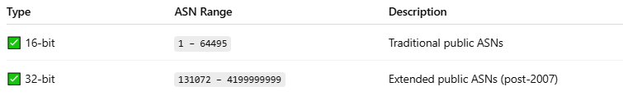
Type | ASN Range | Description
✅ 16-bit | 1 – 64495 | Traditional public ASNs
✅ 32-bit | 131072 – 4199999999 | Extended public ASNs (post-2007)
These ASNs are allocated by Regional Internet Registries (RIRs) like RIPE NCC, APNIC, ARIN, etc.

📦 Example Use Case
# Source: Chatgpt (GPT‑5 Mini) at [12/15/2025]
If an ISP, data center, or enterprise wants to:
- Connect to multiple internet providers (multi-homing)
- Advertise their own IP prefixes to the internet
- Control routing policies with BGP
They need a public ASN — e.g., AS15169 (Google), AS3356 (Lumen), AS16509 (Amazon).

🧾 Example BGP Update with Public ASN
# Source: Chatgpt (GPT‑5 Mini) at [12/15/2025]
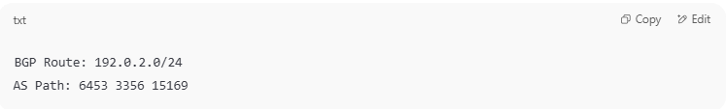
BGP Route: 192.0.2.0/24
AS Path: 6453 3356 15169

- 6453 = Tata Communications
- 3356 = Lumen
- 15169 = Google
Each AS number here is a public ASN — visible globally.

🌍 Where You Get One
# Source: Chatgpt (GPT‑5 Mini) at [12/15/2025]
You request a public ASN from your region’s RIR:
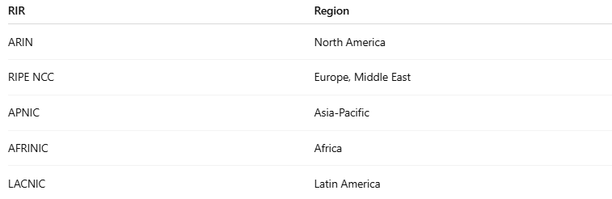
RIR | Region
ARIN | North America
RIPE NCC | Europe, Middle East
APNIC | Asia-Pacific
AFRINIC | Africa
LACNIC | Latin America

✅ Summary
# Source: Chatgpt (GPT‑5 Mini) at [12/15/2025]
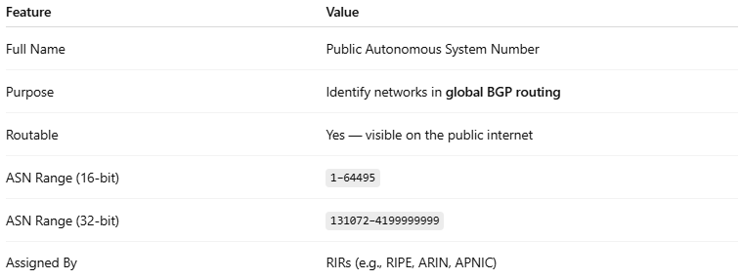
Feature | Value
Full Name | Public Autonomous System Number
Purpose | Identify networks in global BGP routing
Routable | Yes — visible on the public internet
ASN Range (16-bit) | 1–64495
ASN Range (32-bit) | 131072–4199999999
Assigned By | RIRs (e.g., RIPE, ARIN, APNIC)

